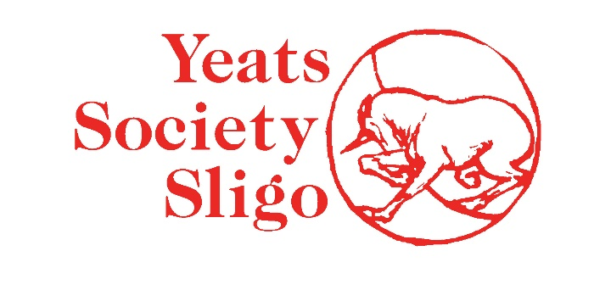
JANUARY 2022
ENVIRONMENTAL POLICY
We aim to be a beacon of good practice, to limit our pollution and waste, save energy and practise recycling.
We encourage our staff and our visitors to know that we care about the environment, believing that this will help them to be more aware of our collective impact on the environment.
To date, we have changed all our lighting to LED and most lights also now switch off when we are not in the room. We have reduced our reliance on oil central heating and have ensured that we have insulated windows and chimneys where possible. Damaged windows have been replaced. We have removed paper handtowels and use controlled hand dryers in bathrooms. We also use controlled taps for water. We turn off printers and desktops at night.
In our shop, we try to buy local/Irish produce to reduce our carbon footprint and we make strenuous efforts to avoid imports where possible. We use bags that are recycled and recycle our own waste/rubbish in the Building. We encourage visitors to do the same.
Our aim this year, 2022, is to derive our electricity from a company offering 100% green energy.
We will continue to seek ways to reduce our carbon footprint and to engage with visitors about the importance of understanding our environment.
All visitors and staff should feel able to engage with our environmental programme, in the same way they do with our exhibition and education programmes, and with just as much integrity. Our environmental policy and action plan lay out a clear structure for maintaining and building upon this good practice, and responsibility for environmental performance is held by the Gallery Manager.

