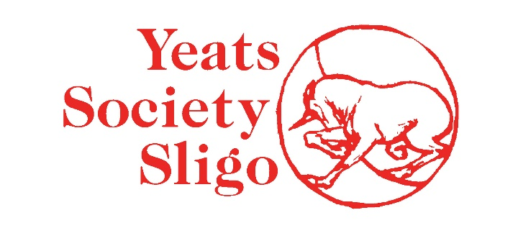
JANUARY 2022
Code of Conduct for Customers, Performers and Members of the Public

This Code of Conduct has been established for all those who use the facilities and have dealings with Yeats Society Sligo, including customers, performers and members of the public.

Yeats Society Sligo aims to provide the highest quality of service in a safe and secure environment. In order to achieve this, we would ask those who interact with us and use the facility that the following behaviour is not acceptable:

- Behaviour which is disruptive and interferes with the use and enjoyment of the
- facility by others.

- Harassment of staff or members of the public by use of abusive, racist, obscene or
- threatening language.

- Use of violence or threat of violence toward staff and/or members of the public.

- Malicious damage to and/or theft of Yeats Society Sligo property.

- The use of illicit drugs while using Yeats Society Sligo facilities.

- Smoking in public areas within the Yeats Society premises.

In turn, we commit that our staff will behave in a manner that is professional, helpful and friendly to all visitors.
Please help us to encourage the responsible and considerate use of Yeats Society Sligo facilities by observing this Code of Conduct for customers, performers and members of the public.

