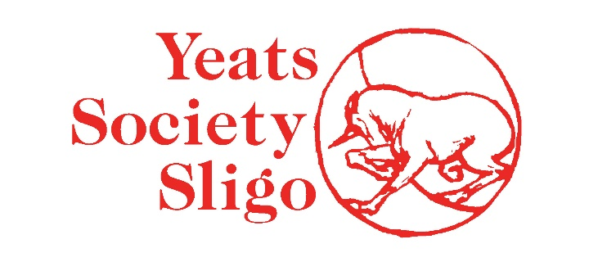
JANUARY 2022
ACCESS POLICY
Yeats Society Sligo recognises and acknowledges people’s differences and aims to support them with their individual needs. We support equal access and oppose all forms of unlawful or unfair discrimination.
Yeats Society Sligo is based in the Yeats Building which is 126 years old. We aim to be very welcoming and accessible to all and we are committed to making your visit as easy and enjoyable as possible. Certain parts of the Building have restricted access because of its age and the fact that it is a protected and listed building.
Please note that there is no lift facility available in the Yeats Building. The Building is over two floors and access is via a staircase.
Please let us know how we can help you to gain access. We have a ramp which we can put in place for those who require it and we are happy to do so.

