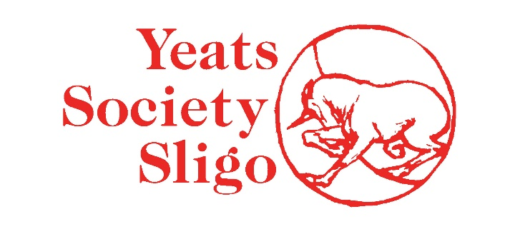

ARTISTS PAY POLICY
JANUARY 2022

Yeats Society Sligo believes that arts professionals should be paid fairly for their work. We recognise our responsibility in the provision of equitable and fair remuneration and contracting within the arts. We are committed to the principle of fair remuneration for professional artists and aspire towards best practice rather than minimum standards in this area.

An artist fee is financial compensation for expertise, time and services. It does not imply the transfer of ownership or rights from artist to the contracting party. Any transfer of ownership or rights must be negotiated between the artist and the contracting party under a separate agreement.

Fair artist fees equate to what is asked of an artist in terms of their time, input and expertise. They account for the status of the artist and reflect the value created by their engagement. Yeats Society Sligo is committed to paying artists fairly, to gender pay equality & to assisting artists & freelance arts professionals develop sustainable careers. We also believe strongly in paying artists promptly.
Although we are not funded by the Arts Council, we pay visual artists, poets and writers according to the Arts Council rates.

We respect every artist's right to negotiate upwards on any fee offered. We are always prudent with our budgets, so if the fee level is beyond our capacity, we either agree a level both parties are happy with or we do not programme the event.

We also cover travel & accommodation & provide subsistence at industry recommended rates.

We believe in the importance of transparency on matters of pay and working conditions, and that sharing this information publicly is to the benefit of all artists.

